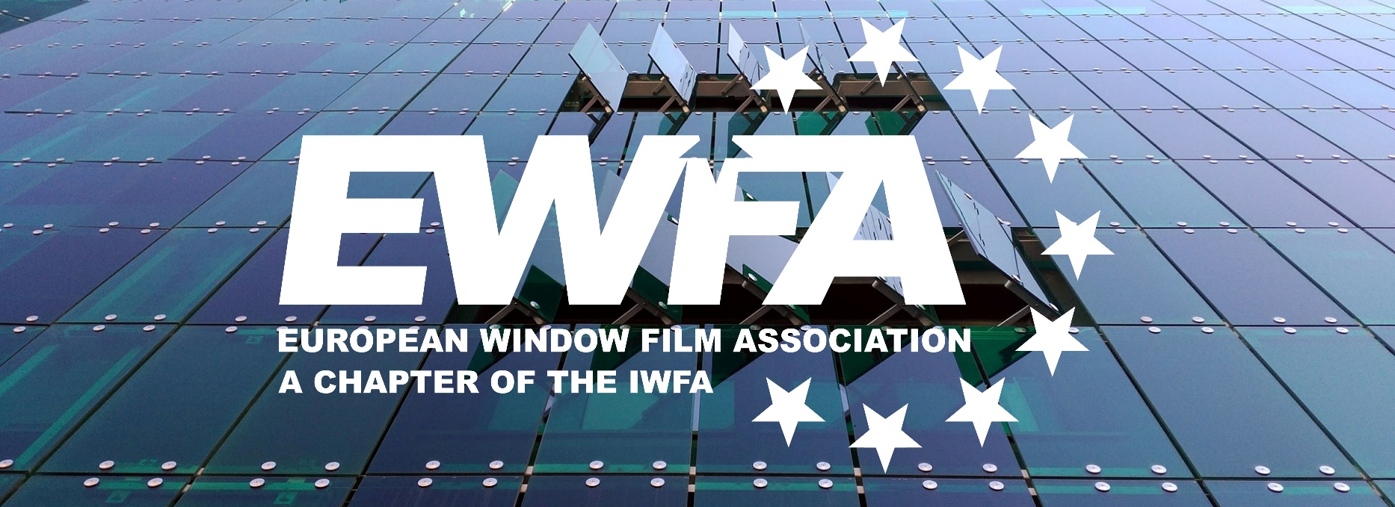

EWFA MEMBERSHIP APPLICATION FORM

EWFA, the European Window Film Association represents and seeks to further the interests of the window film industry. The organisation brings together manufacturers and distributors with the purpose of promoting window film products on the European continent and highlighting their innovative performances and properties in the automotive and architectural aftermarkets.
The EWFA being a Chapter of the IWFA (International Association for Window Film), membership applications will be subject to confirmation by the EWFA Management Council and the IWFA Board of Directors and should not take longer than a calendar month. All applicants for membership in the IWFA, either directly or through one of its Chapters, such as the EWFA, must agree to the IWFA Policies and Procedures before the application can be accepted for consideration.

Organisation Details
Organisation Name: Click or tap here to enter text.
Trading Name (if different): Click or tap here to enter text.
Address: Click or tap here to enter text.
City: Click or tap here to enter text.
Postal Code: Click or tap here to enter text.
Country: Click or tap here to enter text.
Phone: Click or tap here to enter text.
General Email: Click or tap here to enter text.
Website: Click or tap here to enter text.

Main Contact Details
Name: Click or tap here to enter text.
Role: Click or tap here to enter text.
Phone: Click or tap here to enter text.
Email: Click or tap here to enter text.

Organisation Description
Description of your organisation and its relationship with the window film industry (please mention for how long have you been in this industry). Note that this description will be used for promotion of your company by EWFA (e.g. website and social media).

Click or tap here to enter text.

Associated and/or Subsidiary Companies and Branches
Total number of associated and/or subsidiary companies and branches:
Are they in the window film business as well?
Please provide full contact details:
Click or tap here to enter text.

Membership
Kindly note that all memberships will be managed and invoiced through our mother organisation, IWFA. For all categories, half of the amounts are invoiced as payable by 1 January and the other half payable by 1 July of each year.

As the representative of my organization, I commit to pay for the annual membership fees in due time and according to the membership fee structure.

☐ I am a MANUFACTURER Membership annual fee: $20,000 + blind fund.
☐ I am an ALIGNED DISTRIBUTOR Membership annual fee: $ 1,700.
☐ I am a NON-ALIGNED DISTRIBUTOR Membership annual fee: $ 2,200.
☐ I am an ASSOCIATE MEMBER No membership annual fee.

I confirm:
☐ My organisation agrees to the IWFA Exhibit A.
☐ My organisation agrees to the IWFA-EWFA Code of Ethics.

***

Date: Click or tap here to enter text.
Place: Click or tap here to enter text.
Signature: Click or tap here to enter text.

This Membership Application Form is to be filled in and sent by email to: info@ewfa.org.


